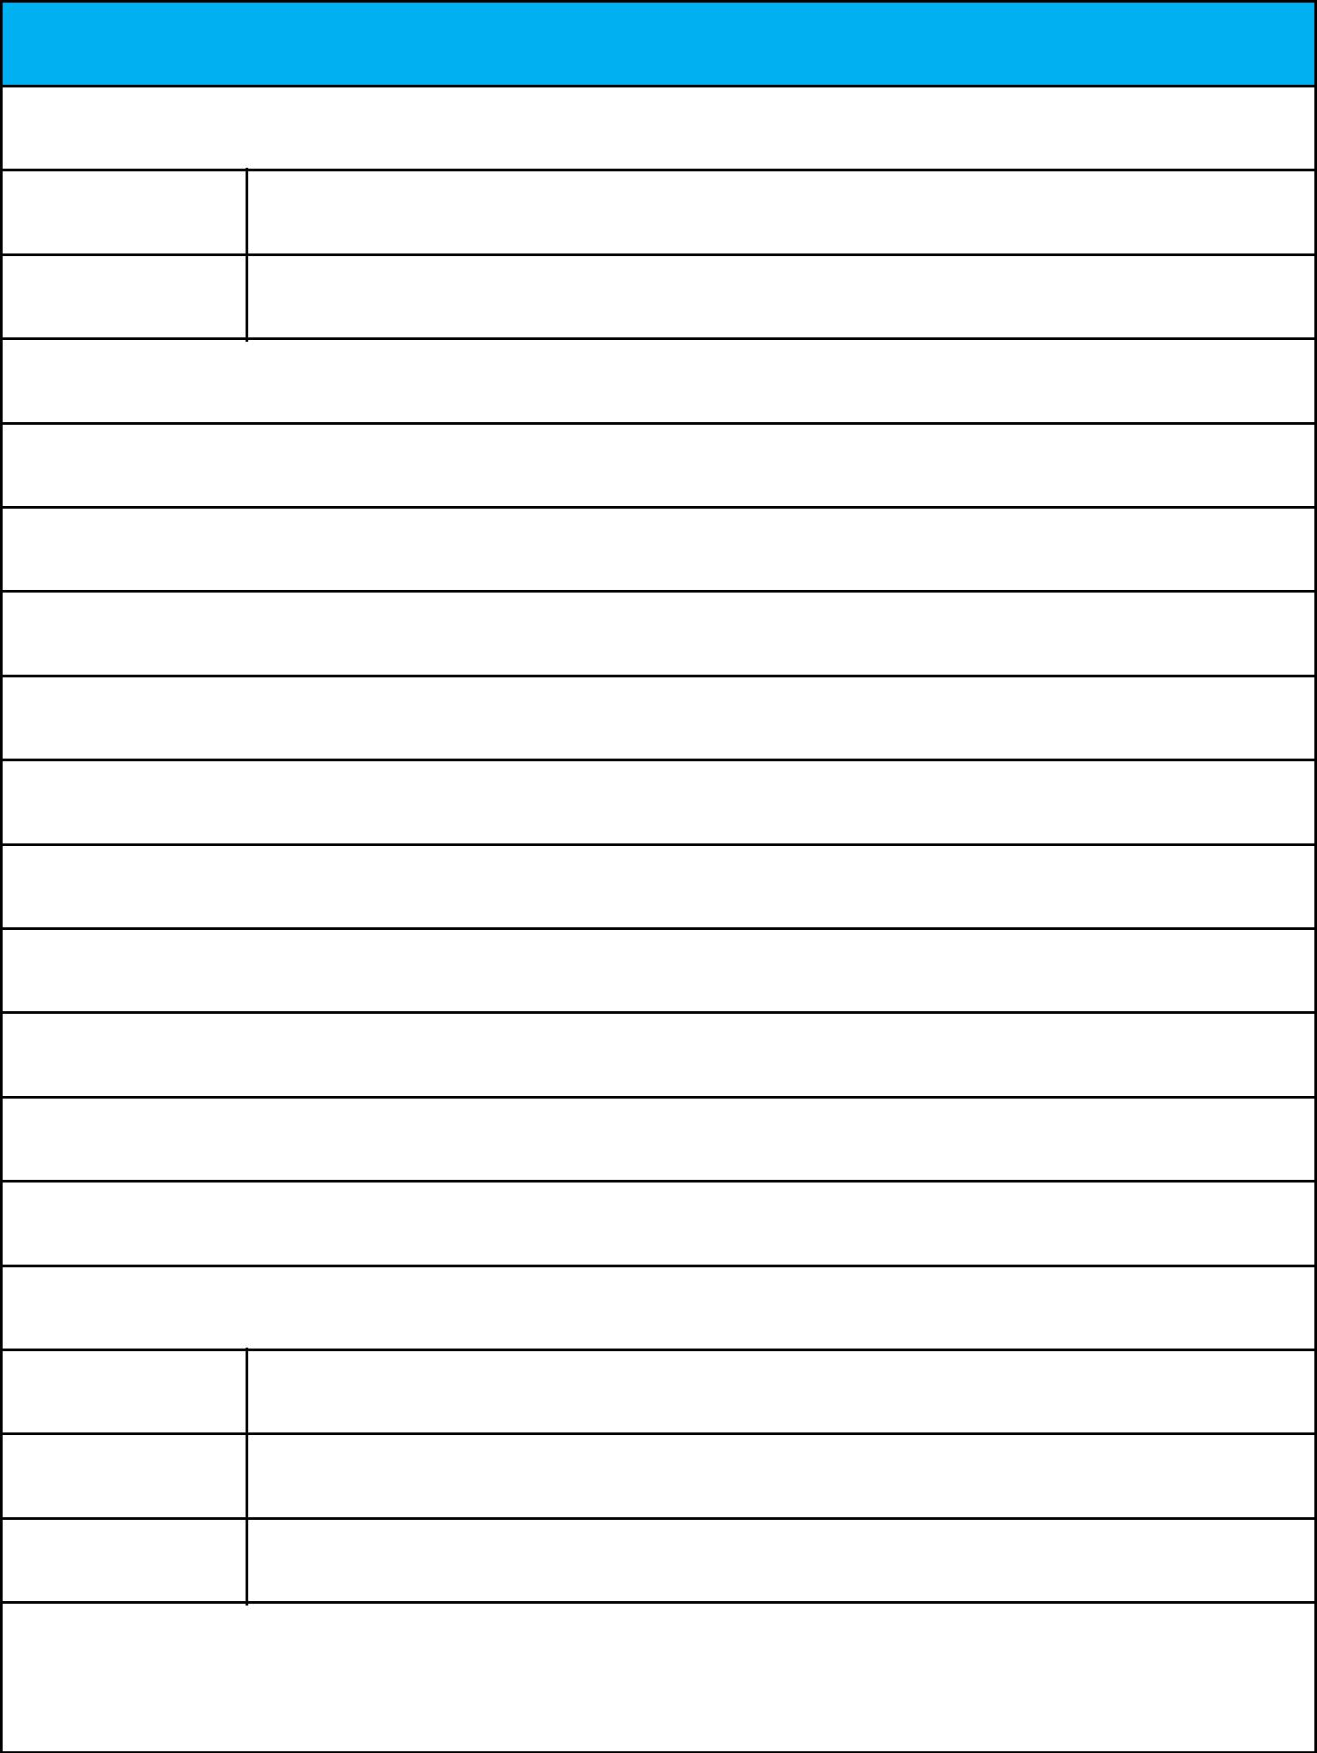
Rent Receipt Template

1. Employee details

Employee ID E5488108

Full Name G.Maruthamkumar

2. Address of the rented house

Flat D2,Fifth floor, Newry Celestial,Paruthipet,Avadi,Chennai-600071

CITY : Chennai

STATE: Tamil Nadu PIN CODE: 600071

3. Rent details

Received with thanks from (employee name) Mr./Ms. G.Maruthamkumar

sum of Rs. 1,26,000

(Rupees: One Lakh and eighty thousand only)

towards the rent of the above-mentioned residential premises for the month from April 2020 to Mar 2021

Mode of Payment (Cash/Cheque/Online) ...Cash.................................. Payment Dated: ………...........

4. Landlord Details

Permanent account

number (PAN) BLHPN5503J

Full Name M.P.Nagarani

Landlord Signature

and Date

Note: The HRA tax benefit is applicable only for the amount paid towards rent. Payment towards other expenses like maintenance, water, electricity, food, security deposits, late payment charges etc. are excluded. If other expenses are being paid along with the rent, the rent receipt should contain a break-up of all the components paid.

